# W2D2 Homework

# Question 1

Table emp, order by ename increasing，which one or more are correct?

A.select ename , salary from emp   order by ename asc

B.select ename , salary from emp   order by ename desc

C.select ename , salary from emp   order by salary asc

D.select ename , salary from emp   order by ename  ;

# Question 2

Table EMPLOYEES

EMPLOYEE_ID        NUMBER          Primary Key

FIRST_NAME             VARCHAR2(25)

 LAST_NAME              VARCHAR2(25)

Which one insert one record to the table correctly?

A. INSERT INTO employees(employee_id) VALUES (1000);

B. INSERT INTO employees (first_name,blast_name) VALUES (‘John’,’Smith’);

 C. INSERT INTO employees VALUES(1000,’John’,’NULL’);

D. INSERT INTO employees VALUES (‘1000’,’John’);

# Question 3

SELECT name, rank, serialNo FROM employee.

Which one to get the value of first column of rs?

A. rs.getString(0);

B. rs.getString("name");

C. rs.getString(1);

D. rs.getString(“ename”);

# Question4

At first in database, create a table Employee, id is primary key.

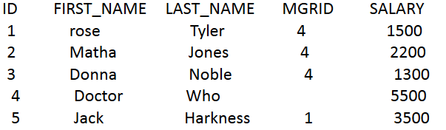

1. Create a table, and insert a record to the table, and print out all the data in the table

(6 Alex Lee 1 4500)

1. Modify the last_name to “Tate” whose last_name is “Jones” , and save it to database. And print out all the data in the table.

# Question 5

Why we use Class.forName?

The **java.lang.Class.forName(String name, boolean initialize, ClassLoader loader)** method returns the Class object associated with the class or interface with the given string name, using the given class loader.

The specified class loader is used to load the class or interface. If the parameter **loader** is null, the class is loaded through the bootstrap class loader. The class is initialized only if the **initialize** parameter is true and if it has not been initialized earlier.

# Question 6

What’s the difference between Statement and PreparedStatement?

**Statement** is used for general-purpose access to your database. Useful when you are using static SQL statements at runtime. The Statement interface cannot accept parameters.

**PreparedStatement** Use the when you plan to use the SQL statements many times. The PreparedStatement interface accepts input parameters at runtime.

# Question 7

How to close the resultset, statement and connection after we finished the database operation? Write the codes.

Resultset.close();  
Statement.close();  
Connection.close();